**COMPUTER NETWORKS - CSA07**

**Parthibhan .R**

**192224275**

**EXPRIMENT 2:-**

Configuration of Topologies using Packet Tracer (Bus, Ring, Hybrid)

Github Link:- <https://github.com/parthibhan007/CSA0748-computer-network/tree/main/expriment%203\>

1.Bus Topology:-

Simulation:-

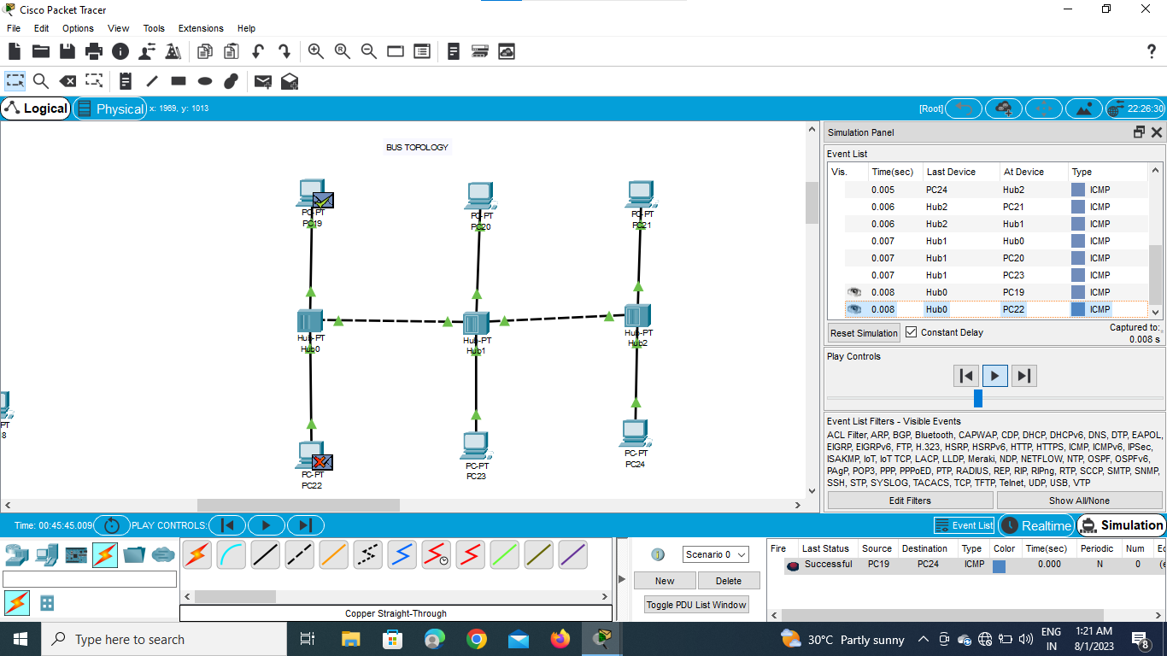

Real Time:-

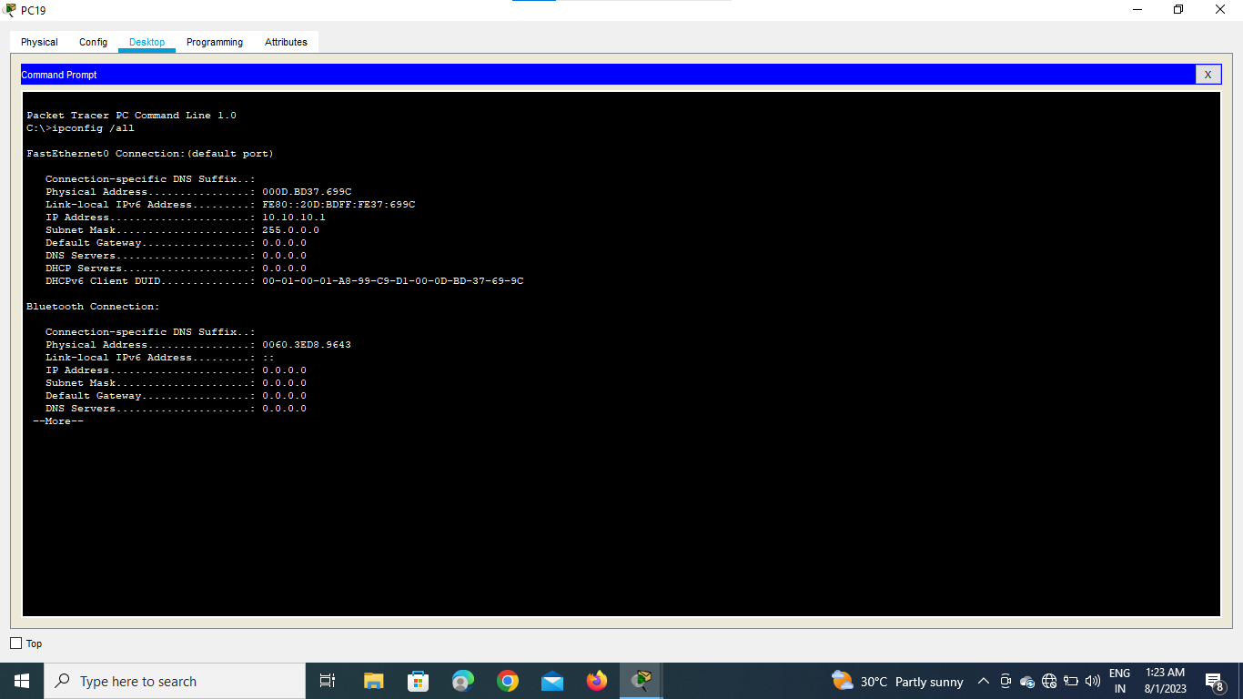

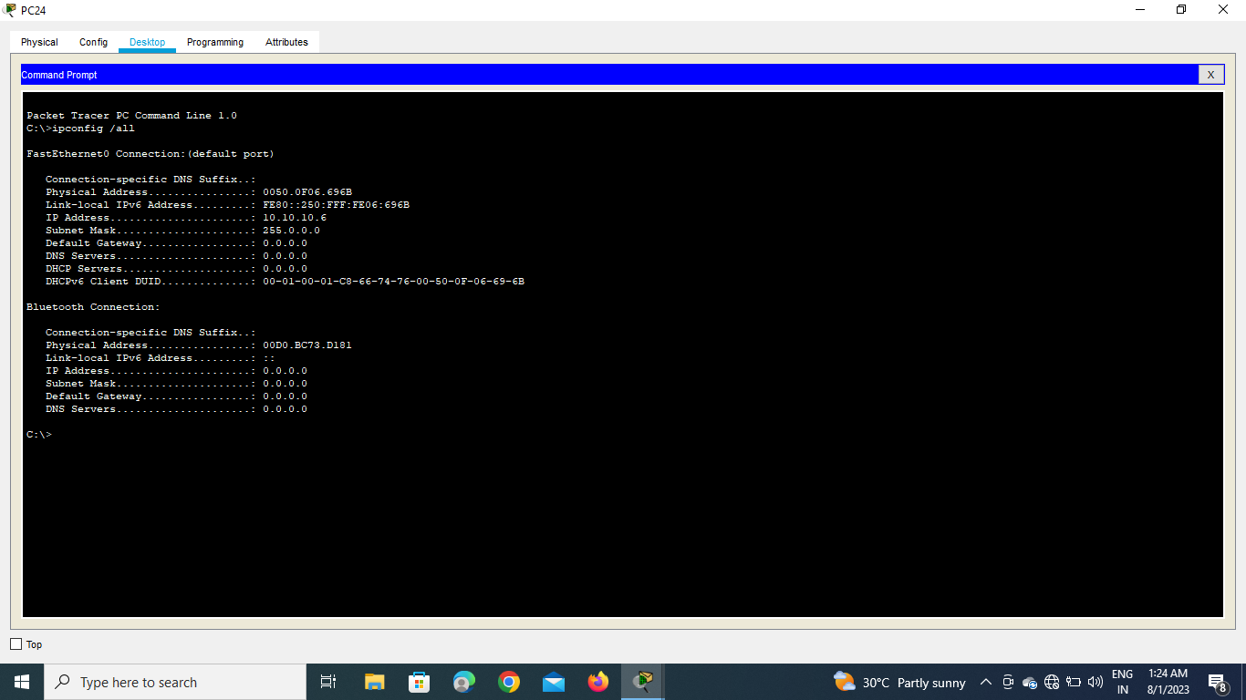

2.Ring Topology:-

Simulation:-

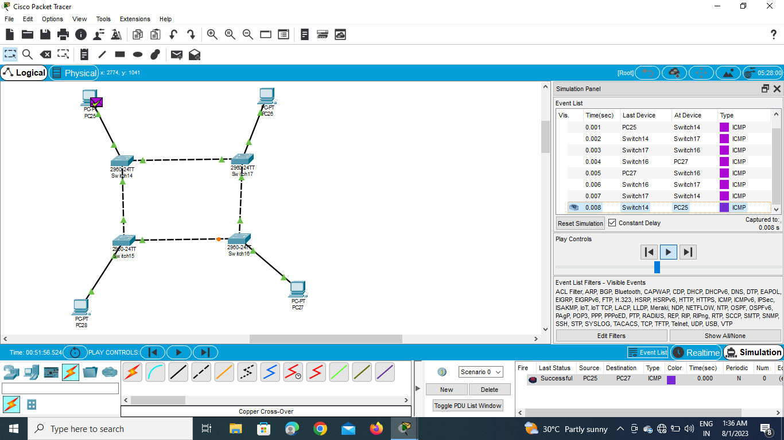

Real Time :-

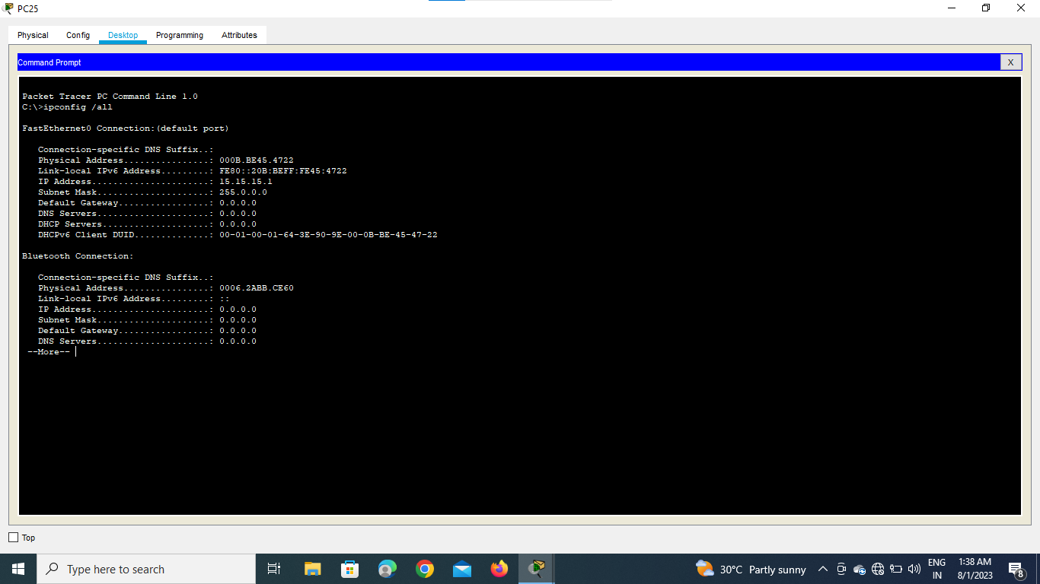

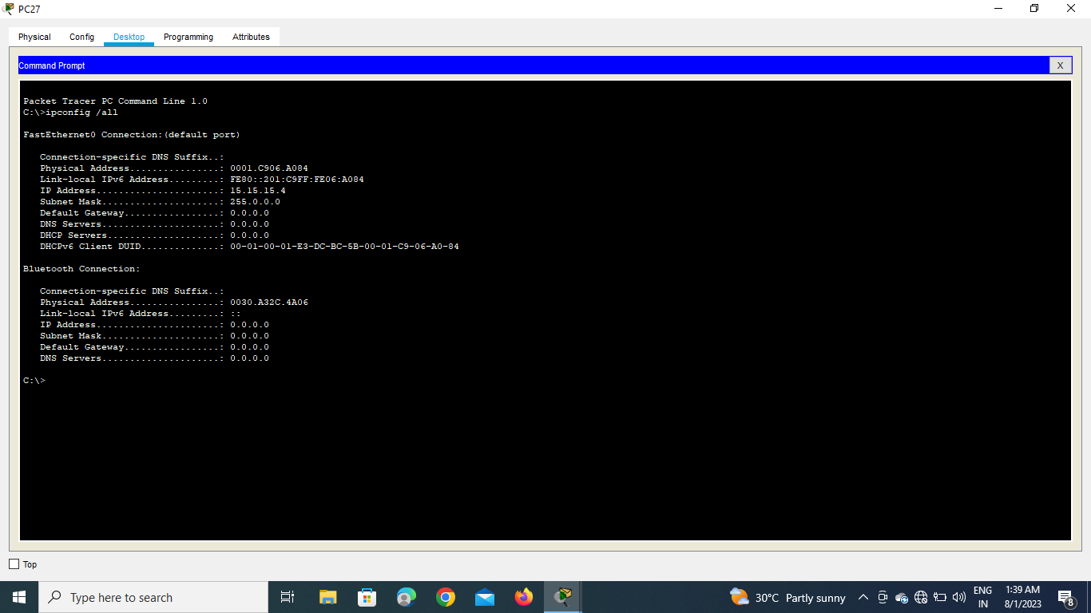

3.Hybrid Topology:-

Simulation:-

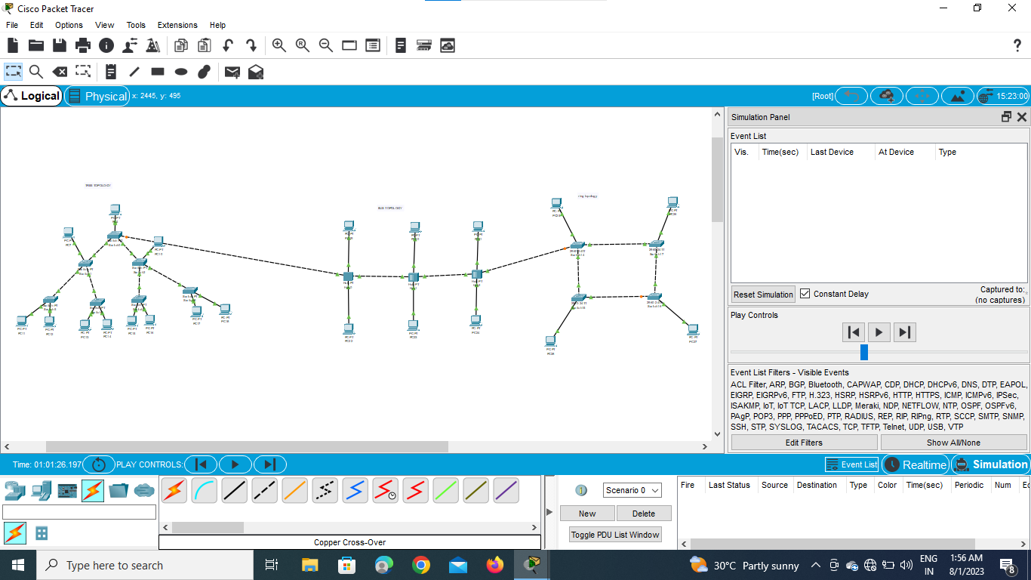

Real Time:-

